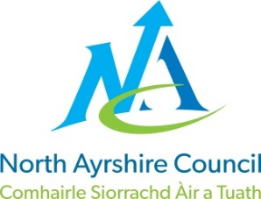
COMMUNITIES & EDUCATION DIRECTORATE
Executive Director : Audrey Sutton
Cunninghame House, Irvine KA12 8EE
Tel: 01294 310000 www.north-ayrshire.gov.uk

IRVINE ROYAL ACADEMY
Head Teacher : Linzie Sloan
Kilwinning Road
Irvine
Ayrshire KA12 8SJ

Telephone : 01294 278756
Email : irvineroyal@ea.n-ayrshire.sch.uk

Dear Parent/Carer

iPayimpact Accounts

iPayimpact is used in school to purchase school meals and snacks but will also be used for trips, events, tickets, and the school shop so that the entire school is cashless. You can access this through a desktop PC, tablet, or a mobile phone enabling you to review payments, purchase history and current balance anytime, anywhere.
- If not previously registered on the site. Go to https://www.ipayimpact.co.uk
- Click on the Register button
- Enter the Child Account Ref of your child.

Child Account Ref for <Child Name>: | <XXXXXXXXX>

- Username – enter a username that you will remember. This will be required each time you login to your account
- Email – enter a valid email address
- Confirm Email – must be the same email address as entered in the previous box
- Password – enter a password
- Confirm Password – must be the same password as entered in the previous box
- Maths Test – please insert your answer
- Agree to Terms – Please tick this box. You can view the terms as required.

- An email will be sent to your email account. ACTIVATE your account by clicking on the link provided in the email. This will ACTIVATE your account and allow you to Login using the credentials you entered during the registration process.

- LOGIN to your account
  - Update your profile (personal information) and save

If you have other children at this school or other schools and you have received a similar email to this, you can link them to your new parental account:
- LOGIN to your account
- Click on the Child Accounts tab
- Click the Link a New Child Account button
- Enter the Child Account Ref for the child – see this letter or other similar letter
- Click Find School and Account – select the school from the list (if offered)
- Click the Link Account button

Should you have any questions on the above, please do not hesitate to contact the Facilities Management support team at the following address: onlinecashlessqueries@northayrshirecouncil.gov.uk

Yours sincerely

Alison MacMaster
Education Business Officer

