**Ambition, Integrity, Equality, Respect, Responsibility**

**Responsibility, Ambition, Integrity, Equality, Respect**

**Integrity, Equality, Respect, Responsibility, Ambition**

Irvine Royal Academy

Higher Physical Education

Basketball Block

Social and Physical Factors Impacting Performance

Features Covered

Social

* Self-Conduct
* Team Dynamics

Physical

* Tactics



[](http://www.google.co.uk/url?sa=i&rct=j&q=&esrc=s&source=images&cd=&cad=rja&uact=8&ved=0ahUKEwjcvZG5ls7QAhXCaxQKHZx4AA0QjRwIBw&url=http://combiboilersleeds.com/keywords/talking-1.html&psig=AFQjCNGI3osY6BcckQK8mZqIJ8YTSg7srw&ust=1480516106462030)

**Contents Page**

|  |  |
| --- | --- |
| **Page** | **Content** |
| 1 | Front Cover |
| 2 | Contents Page |
| 3 | Introduction to the Course |
| 4 | Factors Impacting on Performance |
| 5 | Physical – Role Demands |
| 6-7 | Team Strengths & Weaknesses and Principles of Play |
| 8 | Social - self-conduct |
| 9 | Team dynamics |
| 10 | Methods of collecting information |
| 11 | Physical – Video Analysis and Match Analysis Sheets |
| 12 | Knowledge of Results |
| 13 | Match Analysis – Initial Data Sheet |
| 14 | Match Analysis – Focussed Data Sheet |
| 15 | Social – Co-operation Self-reflection |
| 16 | Team dynamics questionnaire |
| 17 | Questionnaires |
| 18 | Approaches to developing performance |
| 19-21 | Physical – Fast break, Pace of Practices, walk / run through rehearsals, opposed / unopposed practice and group work. |
| 22-24 | Zone Defence, Conditioned games |
| 25 | Social – Role models and use of model performers |
| 26 | Team building |
| 27 | Team talks |
| 28 | Recording, Monitoring and Evaluating |
| 29 | The purpose of monitoring and evaluating |
| 30 | Training Diary and monitoring performance development |

**Introduction to the course**

**Course content**

When studying Higher Physical Education you will learn about your own performance and how it can be improved. The process you go through will require you to reflect on what you already know from your study of PE and ask you to apply this knowledge further to unfamiliar situations.

You will learn about the factors that impact on performance and you will implement and evaluate approaches to develop performance further. This will be internally assessed. You will be required to demonstrate a broad and comprehensive range of complex movement and performance skills in TWO physical activities to pass the Performance Skills Unit.

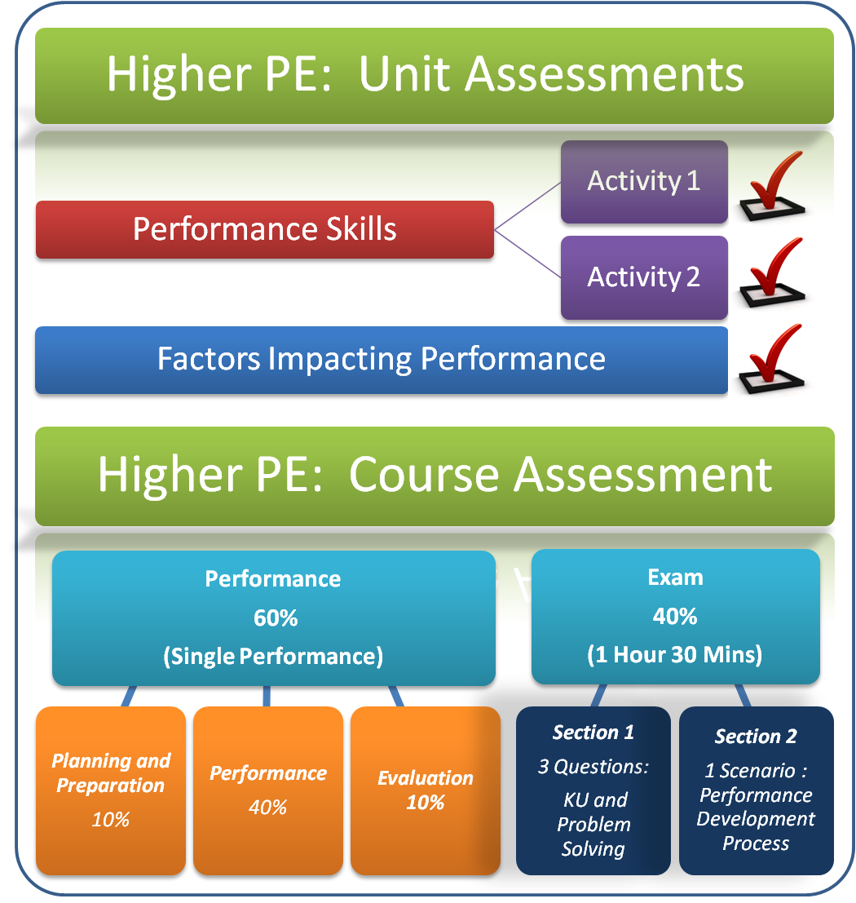

[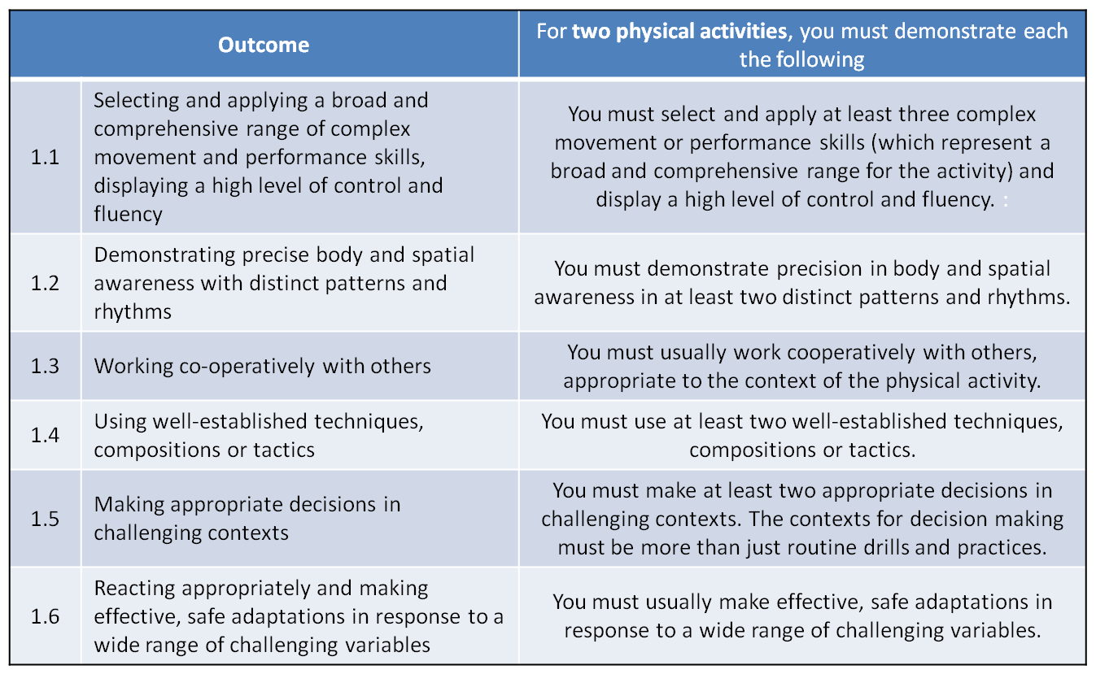](http://blogs.kincorth.aberdeen.sch.uk/higher/files/2013/12/HIGHER-PERFORMANCE2.png)

Factors Impacting on Performance

(Features)

|  |  |
| --- | --- |
| **Physical (Tactics)** | **Social** |
| Role Demands | Self-conduct |
| Team Strengths & Weaknesses | Team Dynamics   * Co-operating with others * Contributing to a team * Relationships |
| Principles of Play |

The information in this section explains how different **factors** can have a **positive and negative impact on your performance** when competing in Basketball.

The two factors we will focus on are **social and physical.** These factors are broken down into **features** and examples are provided explaining how these features will positively or negatively impact your performance.

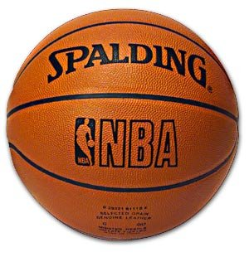

**Physical Factor**

**Role Demands**

***Your role is the part you play in an activity e.g. performer or playing role (e.g. guard centre, forward) or a non-playing role (referee, time-keeper, coach). Demands are the qualities required to fulfil the role effectively.***

**Impact on Performance**

Role demands relate to your own **personal strengths and weaknesses** and whether these are suited to a certain playing or non-playing role. For example, the team captain must demonstrate leadership. As a captain you are expected to encourage, motivate and communicate with your team mates. A captain can also pass on tactical information from the coach/manager to those on the pitch. If the captain fails to do this then the team may be confused about their own role and positions they should be taking up during the game. You must consider your own personal strengths and weaknesses when choosing your role within the 3 Man Fast Break Strategy.

**The Guard** will usually be one of the smaller players in the team and will be responsible for bringing the ball up court to initiate the team’s attack. Most of their scoring opportunities will come from either driving (dribbling) to the basket for a lay-up or shooting from outside the key area. They are the player most likely to attempt three point shots. A talented guard will be able to use their dribble to move close to the basket, not necessarily for a shot, but to draw the defence towards them so that they can pass the ball off to a team mate in a better position for the shot. This demands that they can also pass the ball and are able to ‘read’ the movements of team mates so they can pass at the right time. The player who takes the guard position is frequently one of the most experienced players because from this position they will direct their team’s attacking play. For this reason they are often referred to as the ‘playmaker’.

**The Centre** is usually the tallest player in the team as they play close to the basket both in defence and attack. The centre will be expected to make shots from close to the basket (usually under pressure from close marking opponents). They have good footwork so they can free themselves in the area under the basket to receive a pass before shooting. They are also good at winning defensive and offensive rebounds for the team.

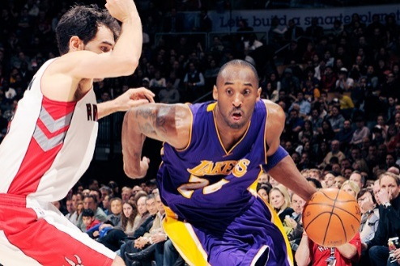**The Forward** plays on either the right or left hand side of the court. They will be among the taller players in the team and will be able to drive to the basket and perform accurate lay-ups. They will also be able to shoot from the corners and sides of the court. They must be prepared to set screens to help free a team-mate for a drive or shot. A forward must also be prepared to move in to gain attacking rebounds should a shot be missed.

***Team Strengths and Weaknesses should be considered before choosing a tactic within an activity. It is important to consider your opponent’s strengths and weaknesses as well as your own strengths and weaknesses*.**

**Team Strengths & Weaknesses**

**Impact on Performance**

It is important to select a strategy that maximises your team strengths, minimises your team weaknesses, minimises your opponent’s strengths and exploits your opponent’s weaknesses. For example, the fast break strategy would be a good choice if you had quick players who could cope with performing skills at a fast pace or if a team were weak at breaking down defences. It would also be a good choice if your opponents had a strong defence and were weak at both shooting from long range and rebounding. It would also be sensible to consider the strengths and weaknesses of individual players and role related demands when analysing your own team’s strengths and weaknesses.

**Principles of Play**

***Plans and formations a team adopts before the game starts and during the game to increase their success in attack and defence. These can include some of the following*:**

**Width**

This is having a spread of players across the playing area and relates to the space between players across the pitch or court.

**Impact on performance**

When players create width in attack: they have more space and time in which to work and execute skills; it puts pressure on the defence by stretching them and creates holes in the defence called space; space provides more time and possibly more 1v1 situations and gaps for players to run through. This means that opposing players will have to work much harder, as they have to cover more space. Width in defence is important to ensure that there is a spread across the playing area to cover attacks through the middle or the wide areas. Within the fast break strategy width in attack is created by the supporting runs made by the forward and the centre as the guard dribbles up the middle of the court (Transition Phase). This drags opponents out of position, creates space and opens up gaps for attackers to run into or the ball to be played into.

**Penetration**

This is the ability to move into space, break through and/or get in behind a defence.

**Impact on Performance**

This can be achieved by players moving into space or driving at defenders in 1v1 or overload situations. In basketball, forwards often use penetration when making a run in behind the defence to receive a pass close to the basket from their team-mate.

**Depth**

Depth involves having a player further back than the others and can be utilised in either defence or attack.

**Impact on Performance**

Depth in defence, often referred to as lines of defence, has a player covering behind the defender so that if the 1st defender is beaten there is still another to get by before being through on goal/basket. For example, some football teams operate with a sweeper behind the back 3 or 4 to provide a second line of defence. Depth in attack is usually when a player drops further back from the goal/basket often to provide a passing option to retain possession. For example, within the fast break strategy depth is created by the positioning of the players in the attacking phase (Triangle Shape). In particular, the guard should stay at the top of the key after he/she plays the bounce pass to the forward. Depth provides **support** to the forward by providing passing/attacking alternatives should he/she be unable to perform the lay–up.

**Support**

Support can be similar to depth as it is mainly about providing options to teammates in attack and providing cover in defence. Support can also come from team-mates in front or in wide positions.

**Impact on Performance**

Support is an important principle of play in team activities. For example, support play in Rugby involves helping the ball carrier advance the position of the ball. Options and support are vital to keeping the opponents guessing and to help your team break through the opposition defence. Support in basketball is also extremely important to provide cover in defence and more options in attack.

**Delay**

Delay involves slowing down the opposition when defending or holding up an attack.

**Impact on Performance**

Delay in defence: The first priority when losing possession is usually to slow down or delay the attack so that the rest of the defence can get organised and sort back into position. This can be achieved by hustling and jockeying your opponent without over committing yourself. You can also reduce the time and space an opponent has by channelling them away from the danger area and into an area that is well defended or is difficult to attack from. Delay in attack: This is where the attacking player/ team deliberately slow down the pace of the attack to vary the tempo of the game or to hold up the ball. For example, slowing an attack down to maintain possession could be advantageous in order run down the clock when holding a lead.

**Social Factor**

**‘Self-Conduct relates to the behaviour of a performer and their social interactions with players, crowd and officials.’**

**Self-Conduct**

[**https://www.youtube.com/watch?v=lUeTScKOuvY**](https://www.youtube.com/watch?v=lUeTScKOuvY)

**Impact on performance**

The conduct and behaviours of a performer can be very complex since it is often affected by relationships and interactions with others. For example a basketball player may feel intimidated or anxious by an aggressive crowd chanting for them to miss a free throw. A “weaker” referee may be more easily swayed to award a foul or other decisions by the conduct of a home crowd throughout a match. There are written rules of conduct and codes of conduct for all parties to follow.

Professionalism in sport has led to sportsmen/women and officials having to conduct themselves in a more “professional” manner. This can affect how they dress, how they train, how they behave throughout a performance, the things they may say and also how they behave in post performance interviews. Self-Conduct can be placed under a great deal of scrutiny by the general public as well as the media and since they often set an example to younger generations there are a number of expectations on how they must conduct themselves at all times. Failure to conduct themselves correctly can lead to punishment through the rules of the activity, financial fines, suspensions and even loss of their jobs.

In golf, players generally conduct themselves very well. Despite having a deep desire to win most golfers will do all they can to behave in line with the rules and the codes of conduct. They may hope that their opponents don’t hole their putt to win, but they would never cheer, fist pump or laugh when an opponent misses. Win or lose they will generally conduct themselves in a manner showing respect to their opponents, the officials and the crowds watching.

Barcelona striker Luis Suarez is an example of a footballer with poor self-conduct. He has been banned three times in his career for biting an opponent and was also found guilty of racially abusing an opponent during a game.

In basketball lessons, poor self-conduct would involve negative body language or verbal reaction towards a personal mistake, arguing with team-mates/opposition, contesting referee-s decisions or committing intentional fouls. The use of positive praise and playing within the rules would be examples of good self-conduct.

**Team Dynamics**

**‘Team Dynamics is the interaction of performers within a team or group. It is mainly to do with making the team more effective than the sum of its parts. The following features are all important in order to have ‘Good Team Dynamics’.**

**Co-operating with others**

Co-operating is where you work together with others to achieve a common goal.

**Impact on Performance**

Co-operating with others is important when performing the Fast Break as players need to work together in order for the strategy to be successful. Co-operating with others is also important in defence, for example, when double marking an opponent or covering for a team-mate who is out of position. Co-operating with others can also be helpful in practice E.g. In basketball, my team-mate helped me practice my lay-ups by feeding the ball when I was ready. Co-operating with others in practice situations makes learning skills easier as you are able to develop the skill to a competent level without added pressure.

**Contributing to a team**

In any activity, where you work with at least one other person, you will be a member of a team. Within the team you will have to give (contribute) something that helps the team. Each member of the team is expected to contribute and this contribution can determine whether a team is to be successful.

**Impact on Performance**

Making a positive contribution to your team will have a positive effect on the overall performance. For example, in basketball a player may have an idea and suggest how a strategy could be developed in order to making the overall performance better. Also when playing, if your team-mates see that you are working hard and fulfilling your role then they may work harder to ensure that they are also fulfilling their roles. A negative contribution or failure to fulfil your role could result in a poor team performance. If you fail to work hard or perform poorly then your fellow players may also begin to lose faith in your performance.

**Relationships**

Relationships are the way in which your team members regard and behave towards one another.

**Impact on performance**

Relationships can have a profound impact on the potential success of team performance. In basketball, you could have a group of exceptionally talented players that on paper should be successful, but if they have a poor relationship then they will almost certainly produce a weaker performance compared to a team who can work together using the strengths of all its members. Another area where relationships have a major impact is between the coach and player. If you do not get along or have different ideas it would become almost impossible to work effectively.

**Methods of Collecting Information**

The information in this section describes how you will **collect information** on the **factors impacting on your performance** in badminton.

It will also explain the **benefits** and **limitations** of using each method.

The methods of collecting information are as follows:

|  |  |  |
| --- | --- | --- |
| **Activity** | **Factor** | **Methods of collection** |
| **Basketball** | **Physical (Tactics)** | * Video Analysis * Match Analysis * Knowledge of Results |
| **Social** | * Self-reflection * Team Dynamics Questionnaire |

[](http://www.privatelabelnutra.com/supplement-manufacturer-blog/wp-content/uploads/2012/08/shutterstock_102366094.jpg)

**Physical Factor – Tactics**

**Video Analysis**

Recording your performance will allow you to concentrate on the game without having to think about the analysis during the action. You are then able to watch back your recording afterwards to analyse your performance in more depth.

**Advantages**

* It is a reliable form of external feedback as once the performance is recorded it can be viewed over and over again, allowing the performer to focus on different points each time.
* The video also allows you to view the strategy from a different angle which may make it easier to analyse the principles of width and depth.
* As the fast break is carried out at a fast tempo, it may be difficult to analyse specific phases of the strategy, slow motion allows individual players and phases to be observed easily.
* It can be used to view a model performance and compare it to your own performance.

**Disadvantages**

* The video camera often only follows the ball and not the player. This means you miss vital footage of what you actually doing in a game
* Occasionally you will want to see your positioning on the court in relation to others and with the video you may not always get the full court in
* The video may not pick up all the verbal and non-verbal communication that occurs
* When analysing tactics and the social factor looking at the atmosphere of the playing environment can be missed on video

**Match Analysis Sheets**

Match Analysis Sheets are used to record information about your performance during a match. They are usually completed by someone who is watching your performance, however, you can also video your performance and then watch it back to carry out your own analysis.

* In class, we used two different types of Match Analysis; initial and focussed data sheets, both of which involved comparing our performance against model criteria.
* The Initial data sheet allowed us to focus on the three main phases of the fast break by identifying if they were successful or in need of improvement.

*E.g. From the information we were able to identify that phase 1 was performed well but phase 2 and 3 was where the problems occurred, this is when the guard dribbles to the middle and passes to the forward who attempts to perform a lay-up shot.*

* With this information we then used a focused data sheet to collect further information about our specific weakness within the attacking phase (phase 3).
* The focused data sheet allowed us to analyse key principles of play within the attacking phase allowing us to pin point exactly where and why our strategy was failing.

*E.g. From this information we were able to identify that our specific weakness was a lack of penetration in the transition phase / lack of width in the attacking phase.*

**Advantages**

* It can be used in conjunction with video analysis to make data more reliable
* It useful for identifying strengths and weaknesses
* Information collected can be used to help plan a development programme
* It is a permanent record of performance which can be used to monitor/evaluate progress

**Knowledge of Results**

Counting the number of successful attempts allows you to easily measure your success rate as a percentage of overall attempts made.

**Advantages**

* Again, this is a permanent record of performance which can be used for monitoring and evaluating performance both during and after a development programme is carried out.

**Disadvantages**

* The results need to be collected by a knowledgeable observer so that the results are reliable.
* When using as a comparison it is ideal to set-up the same data collection situation which is not always possible and thus can have an impact on the validity of the results e.g. the same opponents, same playing conditions

**MATCH ANALYSIS - INITIAL DATA SHEET**

Analyse how effective your team is at executing the fast break strategy in a 3v3 game of basketball against a similar standard of opposition.

|  |  |  |  |  |
| --- | --- | --- | --- | --- |
| **Attempt** | **Defensive Phase** | **Transition Phase** | **Attacking Phase** | **Knowledge of Results**  **(Basket Scored)** |
| **1** |  |  |  |  |
| **2** |  |  |  |  |
| **3** |  |  |  |  |
| **4** |  |  |  |  |
| **5** |  |  |  |  |
| **6** |  |  |  |  |
| **7** |  |  |  |  |
| **8** |  |  |  |  |
| **9** |  |  |  |  |
| **10** |  |  |  |  |

Key:

√= Successful X = Needs improvement

Criteria:

**Defensive Phase** - Rebound

- Fast, accurate outlet pass played to the Guard

**Transition Phase** - Dribble the middle

- Accurate bounce pass played to the Forward

**Attacking Phase** - Forward just in front of Guard

- Pass collected and lay-up shot taken

**MATCH ANALYSIS - FOCUSSED DATA SHEET**

Analyse the transition and attacking phases of the 3 Man Fast Break in more depth to identify specific weaknesses within the strategy.

|  |  |  |  |
| --- | --- | --- | --- |
| **Attempt** | **Width in Attack** | **Penetration** | **Depth in Attack** |
| **1** |  |  |  |
| **2** |  |  |  |
| **3** |  |  |  |
| **4** |  |  |  |
| **5** |  |  |  |
| **6** |  |  |  |
| **7** |  |  |  |
| **8** |  |  |  |
| **9** |  |  |  |
| **10** |  |  |  |

Key:

√= Successful X = Needs improvement

Criteria:

**Width in Attack** - Both Centre and Forward are in wide positions just in front of Guard

**Penetration** - Guard dribbles the ball down the middle of the court at pace committing any opposing defenders.

- Forward (or Centre) receives pass and has space to drive towards basket and perform lay-up

**Depth in Attack** - Guard remains at the top of the key to provide support

**Social Factor: Self Conduct & Team Dynamics**

**Co-operation Self-reflection**

This method allows you to collect initial data on your current level of co-operation in your activity. It can be completed at the start and end of the block and results can be compared. There are statements on co-operation and you have to select one of four criteria – always, usually, sometimes and never. You should reflect on your performance and tick the box which best describes how you Co-operate in different situations.

|  |  |  |  |  |
| --- | --- | --- | --- | --- |
|  | Always | Usually | Sometimes | Never |
| I have confidence in my team mates |  |  |  |  |
| I have trust in my team mates |  |  |  |  |
| I understand my role / responsibility during games |  |  |  |  |
| I work hard for my team at all times |  |  |  |  |
| I always give 100% regardless of performance/score |  |  |  |  |
| I cover for my team mates and offer support |  |  |  |  |
| I stay positive and don’t argue when things go wrong |  |  |  |  |
| I blame my team mates for mistakes |  |  |  |  |
| I support my team mates whatever their decision |  |  |  |  |

**Advantages**

* Helps you breakdown your whole performance into manageable parts to help identify if it is having a positive or negative impact on your performance
* The criteria on the table indicates the extent (how much) that the factor is having on your performance. This can help priorities areas of performance to develop. E.g. an area of performance that constantly has a “never” response will take priority over an area that constantly has an “always” response.

**Disadvantages**

* You need to be honest with yourself. It will have no relevance if you make up the answer as you are embarrassed or do not want to show a weakness. Your actions have an impact on others.

**TEAM DYNAMICS QUESTIONNAIRE**

The following questions ask about your feelings towards your team. Please **circle** a number from 1 to 9 to show how much you agree with each statement.

|  |  |  |  |  |  |  |  |  |
| --- | --- | --- | --- | --- | --- | --- | --- | --- |
| 1. We all share the same commitment to our team’s goals. | | | | | | | | |
| **1** | **2** | **3** | **4** | **5** | **6** | **7** | **8** | **9** |
| **Strongly Disagree** | |  |  |  |  |  | **Strongly Agree** | |
| 2. As a team we are all on the same page. | | | | | | | | |
| **1** | **2** | **3** | **4** | **5** | **6** | **7** | **8** | **9** |
| **Strongly Disagree** | |  |  |  |  |  | **Strongly Agree** | |
| 3. I like the way we work together as a team. | | | | | | | | |
| **1** | **2** | **3** | **4** | **5** | **6** | **7** | **8** | **9** |
| **Strongly Disagree** | |  |  |  |  |  | **Strongly Agree** | |
| 4. We are all given equal opportunities within the team. | | | | | | | | |
| **1** | **2** | **3** | **4** | **5** | **6** | **7** | **8** | **9** |
| **Strongly Disagree** | |  |  |  |  |  | **Strongly Agree** | |
| 5. We all know our roles within the team. | | | | | | | | |
| **1** | **2** | **3** | **4** | **5** | **6** | **7** | **8** | **9** |
| **Strongly Disagree** | |  |  |  |  |  | **Strongly Agree** | |
| 6. Everyone makes a positive contribution to the team. | | | | | | | | |
| **1** | **2** | **3** | **4** | **5** | **6** | **7** | **8** | **9** |
| **Strongly Disagree** | |  |  |  |  |  | **Strongly Agree** | |
| 7. I am happy with my team’s level of desire to succeed. | | | | | | | | |
| **1** | **2** | **3** | **4** | **5** | **6** | **7** | **8** | **9** |
| **Strongly Disagree** | |  |  |  |  |  | **Strongly Agree** | |
| 8. I am happy with my team’s effort. | | | | | | | | |
| **1** | **2** | **3** | **4** | **5** | **6** | **7** | **8** | **9** |
| **Strongly Disagree** | |  |  |  |  |  | **Strongly Agree** | |
| 9. My approach to playing is the same as my team-mates. | | | | | | | | |
| **1** | **2** | **3** | **4** | **5** | **6** | **7** | **8** | **9** |
| **Strongly Disagree** | |  |  |  |  |  | **Strongly Agree** | |
| 10. Everyone in my team gets along with each other. | | | | | | | | |
| **1** | **2** | **3** | **4** | **5** | **6** | **7** | **8** | **9** |
| **Strongly Disagree** | |  |  |  |  |  | **Strongly Agree** | |

**Analysis of Results**

|  |  |
| --- | --- |
| Look at your completed Questionnaire and write up your teams’ strengths and weaknesses. Consider the example answers below. ***Strengths:***  *- Most of my team shares the same commitment to our teams’ goals.*  *- We sometimes work well together as a team.*  *- I am sometimes happy with my teams desire to succeed.*  *- Most players within my team get along with each other.* | **Strengths:** |
| ***Weaknesses:***  *- As a team we are not always on the same page.*  *- We are not always all given equal opportunities.*  *- We know our roles but not everyone makes a positive contribution.*  *- Some players put more effort in than others* | **Weaknesses:** |

**Questionnaires**

Questionnaires can used to record thoughts and feelings on social factors impacting on a performance.

**Team Dynamics/Group Cohesion Questionnaire**

This is a questionnaire that is used to measure Team Dynamics. In this questionnaire the performer must read 10 statements related to the different features of team dynamics - working with others, contributing to a team and relationships. They then have to circle a number between 1 and 9 to show how strongly they agree with each statement.

In order to identify strengths and weaknesses the performer must reflect on their results and summarise the most significant statements.

**Advantages**

* The statements in the questionnaire are easy to understand and it takes little time to complete.
* Scoring between 1 and 9 makes it easy to identify strengths and weaknesses.
* Questionnaires give you a permanent record of your performance which allows you to look back and compare your results to check for improvement during and after your training programme.

**Disadvantages**

* As questionnaires rely on a performer’s thoughts and feelings the information can only be reliable if the responses are honest. You may have a clouded view of yourself depending on your own view of yourself (we all know someone who thinks they are just great when in reality they have flaws like everyone else).

Approaches to Developing Performance

The information in this section provides you with **approaches** to developing **Emotional** and **Physical (Fitness)** Factors.

Each approach will be **explained** and the **benefits** and **limitations** will be **evaluated**.

The section will also in Co-operate **Mandatory Knowledge** which will have to be applied within your answers for homework tasks and final exam.

For **Basketball** several approaches will be explained and evaluated.

|  |  |  |
| --- | --- | --- |
| **Activity** | **Factor** | **Approach** |
| **Basketball** | **Physical (Tactics)** | Fast Break   * Walk/Run through rehearsals * Unopposed / Opposed |
| **Social** | * Role Models * Team Talks * Team Building |



**Physical Factor – Tactics**

**Fast Break**

**“**The **objective** of the 3 Man Fast Break is to advance the ball up the court quickly for a high percentage shot, either by outnumbering the defence or by not allowing the defence to set up in time.**”**

Positive Impact

* Fast break creates the easiest way to score (lay-up)
* Creates an easy opportunity to break through the defence (2v1 or 3v2 overload)
* Works well against zone defence as opponents have little time to set up zone
* A fast breaking team are better prepared to inbound the ball quickly
* A fast break team discourages opponents from sending to many players to the offensive board to rebound for fear of not having players to defend
* It motivates a team to play good defence and rebound
* A fast break can cause mismatches against player to player defence

Negative Impact

* Speed of attack puts pressure on players
* Ability levels of players must be high
* Could get caught in the opponents half if the ball is intercepted
* Might not be as effective against man-to-man defence
* Could create a mismatch in opponents favour

**Pace of Practices**

How you pace practices as a teacher is dependent on how skilled your pupils are at applying a tactic, or performing a structure or strategy and how quickly they understand the movements involved in what you are asking them to do.

**Walk/Run through rehearsals, Opposed / Unopposed practice and Group work**

When practicing set pieces in team activities, a run through or rehearsal of the play can be very useful to allow players to become familiar with their role and movements within the play. The best way is to gradually increase the pressure of the ‘run throughs’ by using a progression of unopposed practices, opposed (passive) practices and opposed (active) practices.

Walk/Run through rehearsals and Opposed / Unopposed practice are both recognised methods for developing Role Related Demands (Physical)

Partner or Group Work is also a recognised method for improving Team Dynamics (Social)

**Passive defender**

**Definition**: an opponent who applies little or no pressure and is not attempting to gain possession or win points.

**Why**?

* Limited pressure means that you can concentrate on performing your identified technique/ tactic.
* Allows you to perform in a conditioned game like situation.
* Gets you used to performing with defenders in appropriate positions.

**Active defender**

**Definition**: an opponent who is moving and positively looking to gain possession and or score points.

**Why**?

* Allows you to practice skills in a realistic game-like situations
* Encourages you to adapt and learn to cope with the demands of performing identified skills/ tactics under pressure.

As an approach passive/ active defenders can be linked to a variety of training approaches in skills and tactics (Physical). The principle of increasing the movement/ activity of a defender could be seen as spectrum from passive/static to active/ fully involved with a variety of levels of movement/ involvement in between.

**1. Unopposed Play (3V0)**

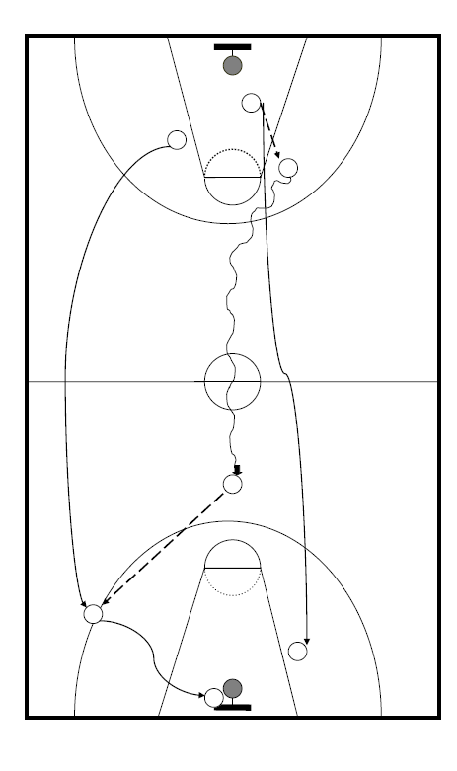Description

Players walk through the Fast Break getting a feel for their roles and responsibilities. Teacher/coach instructs each player where they should be. The drill is repeated over and over with the speed being gradually increased until the team can perform the strategy at game speed unopposed with consistent success.

Explanation

This method allows players to become familiar and understand their role and become confident in it. The teacher/coach talks through the strategy and explains what is expected in each role. This increases each players understanding of each other’s roles and how they relate to each other. This drill develops player confidence as there should be a high success rate with no opposition. The pace of the strategy can also be increased or slowed down when required.

**2. Passive Defence (3v1 and 3v2)**

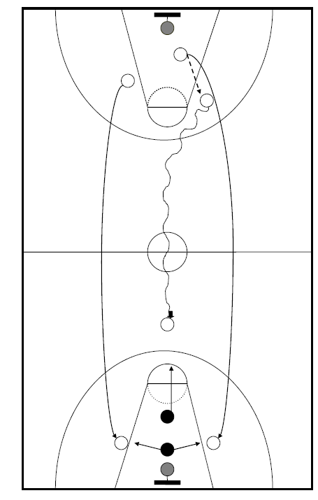

Description

Players perform the Fast Break as normal at game speed. The guard must drive towards the free throw line to commit the first defender. The defender closes down the guard but takes on a passive role (not full out defending but enough to put slight pressure on decision making). The guard then makes an appropriate pass to the forward for an uncontested lay-up. The drill is then repeated until the team can perform the strategy with consistent success. A second passive defender can be added behind the first defender. They will move towards either the oncoming forward or centre in anticipation of a pass being made. This will encourage the guard to make a quick decision on who to pass to.

Explanation

This method is appropriate as each player can practice their role and face situations similar to what they will experience in a game. The defence is passive so it gives players time to make effective decisions and work cooperatively which in turn will raise players’ confidence in themselves and in their team. This drill is also repeated many times which provides the opportunity for players to practice situations over and over again. The teacher/coach is available to provide feedback on performance.

**3. Pressure Drill (3v2 and 3v3)**

Description

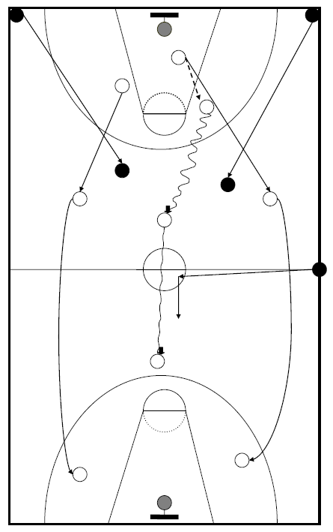Players perform the Fast Break as normal at game speed. As the centre initiates the Fast Break by shouting, “rebound”, two defenders run from the opposite corners of the baseline and become active. The defenders decide who to track. The Guard, who would have received a quick outlet pass from the centre, would then need to make quick decisions based on the actions of the actions of the defensive players. The drill is continued until a basket is scored or defence intercept the ball. The drill is then repeated until the team can perform the strategy with consistent success. A third defender can be added as soon as the guard crosses the halfway line. This defender is positioned at the half way line and they must touch the centre circle with on foot before becoming an active defender.

Explanation:

This method is appropriate as the teams players can practice primarily in their role and face situations similar to what they will experience in a game. The defence is active which allows players to develop their problem solving and decision making skills. The drill only uses two defenders which will develop the teams’ co-operation and mobility further as it creates a 3v2 overload. The attacking team need to work together to take advantage of this. By doing so and achieving success will not only increase the players’ confidence but will develop the teams’ dynamics. By monitoring the success of the strategy, the team can easily monitor how effective they have been in cooperating with each other.

**Zone Defence**

**Aim:** To get back before the opponents attack the basket and to deny space within the key.

**How to play the Zone Defence:**

* When your team lose possession the centre shouts ‘zone’
* All players sprint back up the court quickly and take up positions so that opposition cannot score quickly
* All defenders must face the ball with their knees bent, on their toes with their arms up to block passes through or over the key
* Each defender guards the area (zone) immediately around them and not a particular opponent
* The closest defender must pressure the ball handler
* Other team members must adjust their position relative to the ball whilst making sure the structure of the zone is maintained
* The whole team move as a unit (the centre will communicate with the rest of the team to let them know which direction to move in) to follow the ball, the shape must be maintained at all times.

**Benefits of a Zone Defence structure are:**

* Forces opponents to shoot low positioned percentage shots from outside the key as the defenders are concentrated in a tight area around the basket. This prevents attackers from driving into the key for an easy scoring opportunity (e.g. Lay up).
* Slows down the tempo of game.
* Minimises the possibility of a mismatch e.g. tall against small, fast against slow etc. Allows teams to hide weaknesses that could be easily exposed by man-to-man defence.
* Allows teams to play to their strengths. Roles are allocated on basis of individual’s strengths e.g. physique, skill level, and fitness.
* It allows for the fast break to be played quickly. Fast players positioned at top of key for quick counter attack.

**Limitations of a Zone Defence are:**

* Vulnerable to teams with good long range shooters (3pt shooters).
* A fast break can beat the defence down the court and not allow time for zone to organise
* Opponents can bring the ball up the court unopposed as no pressure is applied until the ball is close to the key
* If individual defensive skills are not developed it will leave gaps and space in the zone

**Conditioned games**

Play in a “game-like” environment that has agreed conditions placed on the game. Conditions can be changes to rules, only using certain skills, playing in specific parts of the court area, different points scoring or using a different number of players

**Benefits of conditioned games:**

* Your practice will be very similar to actual games
* Helps to also develop your decision making skills
* The conditions help you focus on the specific weakness whilst dealing with the demands of an “open” environment

**Game 1: Full Court Man-to-Man**

Each player marks one player on the court. Their aim is to stop that player moving around the court and scoring baskets. This should be a high energy game where individual skill and fitness strengths and weaknesses are highlighted.

**Benefits:**

* Easy to know who you are marking
* If you are more skills and physically fitter you should be able to control your opponent
* Can slow the attack down by putting pressure on attack under their own basket giving rest of team time to get back
* If pressing under basket could potentially get interception and quick attack

**Disadvantages:**

* Very tiring
* If you do not mark your opponent they either have a free run at the basket or someone else needs to mark them creating space
* A lot of defenders crossing in front of each other causing confusion

**Game 2: ½ Court Man-to-Man**

Introduce the idea of saving energy and players will find it nearly impossible to score from inside their own half. Players retreat to their half and only pick up their opponent when they enter into your half.

Benefits:

* Conserves some energy
* Offer more support from defensive team if all in your half
* You can identify your opponent easily when they enter your half allowing you to mark closer
* Marking the area they shooting in, not marking defensive half where they are not so much as a threat

Disadvantages:

* It allows the attack to set up plays unopposed
* Get the ball up court quickly as no ‘delay’ on attack
* Defence need to be back quick – if one player doesn’t’ get back leaves a gap in defence

**Game 3: Zone Defence**

Each player retreats to their ‘D’ and sets into their defence position. They mark the area they have been given and do not move from it until they transition into attack.

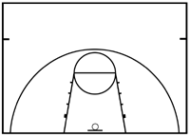

**C**

**F**

**F**

**G**

**G**

**Benefits:**

* Builds up players understanding of why a zone defence can be beneficial comparing it to previous experiences
* See page 22 for full list of benefits and limitations of zone defence

**Social Factor**

**Role Models**

**Definition**- *a person whose character and behaviour is imitated by others who would like to be in the same or a similar position or situation.*

True role models are those who possess the qualities that we would like to have, and those who have affected us in a way that makes us want to be better people. Role models can therefore be used to motivate us to improve our own behaviour and self-conduct.

Role Models can come from the performers own activity or from another activity as it is their personal qualities and behaviours that a performer may take inspiration from.

**Examples**

Andy Murray's relaxed demeanour off the court but die-hard attitude on the court makes him an excellent role model. Murray shows excellent discipline on court by never giving up in matches and not letting losses in previous games affect his performances in the next tournament. Murray’s rival Novak Djokovic also displays excellent self-conduct by playing fairly at all times. Watch the video below of Djokovic’s act of sportsmanship when he awards his opponent a point after a wrong call from a line judge.

**https://www.youtube.com/watch?v=cPvlqjxFQqs – Djokovic’s Act of Sportsmanship**

**Use of model performers**

Comparing and contrasting your performance with a model performer is a good way to establish your training priorities at the beginning, during and conclusion of your personal performance development plan (you have done this through PAR analysis data collection). Model performers exist at different levels of ability. Comparing your ability with a classmates, whose abilities are close to your own, may be useful for establishing your own strengths and weaknesses within that playing environment. At other times it may be worth comparing yourself to a high level performer so that you can see the correct form for playing skills or roles that they adapt to be a successful performer.

Analysing a model performers can be very useful for appreciating in detail all that a performance includes e.g. information about fitness needs, skill requirement and effectiveness of decision making.

***(watch, listen & analyse)***

[***https://www.youtube.com/watch?v=vM54ePnpiJ8***](https://www.youtube.com/watch?v=vM54ePnpiJ8)

[***https://www.youtube.com/watch?v=Mjgi8ue56ac***](https://www.youtube.com/watch?v=Mjgi8ue56ac)

**Team Building**

Team Dynamics are unconscious influences on or within a group of people that have a common purpose (football team/Badminton doubles pairing). These dynamics are created by personalities, relationships, roles within the team and the environment the team has. These can have both positive and negative impacts on the team.

In terms of sports development, team-building exercises are important not for the immediate experience of the activities performed by the team, but also for the group skills, communication and bonding that result. The activity, be it an obstacle course or the pyramid challenge, is merely the means to the end: a high-impact learning experience. Team-building programmes provide realistic experiences that empower individuals to contribute to common goals. The success of most sport teams depends on the ability of individuals to build effective teams.

The main goals of team-building are to improve productivity and motivation. Taking athletes out of their comfort zones, helps groups break down personal barriers, eliminate distractions, and have fun. The benefits of team-building programs are so significant that many teams have incorporated teambuilding strategies into their standard training sessions.

**Some of these benefits include:**

* Improves morale and leadership skills
* Finds the barriers that thwart creativity
* Clearly defines objectives and goals
* Improves processes and procedures
* Improves organisational productivity
* Identifies a team’s strengths and weaknesses
* Improves the ability to problem solve

**Limitations:**

* Clashes in personality and division within the team can lead to demotivation and poor in cohesive performance
* Not specific to a sport so skills still need to be transferred into the training and competitive environment

The development of a group normally goes through the following stages:

**Forming** - the group gets together and a level of formality is common

**Storming**- heightened tension associated with competition for status and influence

**Norming** - rules and standards of behaviour are agreed

**Performing** - group matures to a point where it is able to work together as a team

There are many different forms of interaction in a group. We have social interaction (formation of friends) and task interaction (the way the members co-operate to achieve goals)

**Team Talks**

A really good motivational speech raises our performance by helping us to really focus on what is most important at that moment in time and also help us focus on what we can control rather than what was outside our control. It appeals to the emotions - pride in a country, jersey or organisation, duty to teammates, customers, supporters, personal responsibility or anger. It ignites a passion which causes us to bring extra effort to the task.

The way a speech is delivered which includes the tone and body language accounts for over 90% of the impact that a speech can make. It is suggested that the words alone only account for 7%. I am not saying the words are not important. However, they would only have a very small impact if they are not delivered with the right tone and body language. The speaker needs to have credibility in the eyes of the audience.

[**https://www.youtube.com/watch?v=WO4tIrjBDkk**](https://www.youtube.com/watch?v=WO4tIrjBDkk) **– Any Given Sunday – Inch by Inch**

## **5 tips for an inspiring speech**

**1 Get their attention:**

People tend to have short attention spans. To overcome this, you need to hook the audience immediately — perhaps with an anecdote or a joke. If the subject at hand is relatively dry or has a technical aspect, do not plunge in head-first as you’ll probably lose them by the time you pause to draw breath.

**2 Communicate through body language:**

There’s a reason for the cliche of the GAA coach banging his hurley on the table during a half-time pep talk. It’s not enough to have a good stump speech. You have to communicate belief and self-assurance through your body language.

**3 Silence is your friend:**

In the right circumstances, a dramatic pause can have a powerful impact. Know when to raise your voice — but understand that sometimes letting a hush falling over a room can be just as powerful.

**4 Be self-deprecating:**

Irish audiences prefer speakers to be grounded and not high on their own invective. If you’re pumped — too “American” — you may turn people off.

**5 Be realistic:**

Stirring language on its own is insufficient — you need to convince people that, by focusing on certain actions, they can achieve key goals. Underneath the soaring rhetoric, your presentation must have a core of cold, hard logic.

**Recording, Monitoring and Evaluating**

**[](http://www.brindlemedia.net/wp-content/uploads/2012/11/Evaluate.jpg)**

The information in this section explains the purpose of monitoring and evaluating performance development in Basketball.

It will explain different methods for recording and monitoring performance development for both Emotional and Physical Factors.

**The Purpose of Monitoring and Evaluating Performance**

* Evaluating performance will allow you to see if performance has improved and also if the training programme has worked. You may have to make adaptations/progressions to your approaches.
* If results are positive then this can improve motivation to develop performance even further.
* New strengths and weaknesses can be identified and future development needs can be agreed.
* The information from the evaluation process can also be used to plan a new training programme that will be specific to the new weakness identified.





**Why is a training diary appropriate?**

* The format of the training diary offers an opportunity to clearly identify the aim of each session. This is important as it focuses planning on practices/approaches that are specific to targeted areas, leading to a greater purpose of training.
* A training diary can give an enormous amount of information about what has happened in the past and how training has gone in the past. When [planning](http://www.brianmac.co.uk/plan.htm) future training, information of this kind is invaluable to ensure programmes of work are appropriate and specific to development needs.

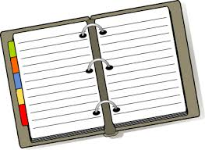

**Monitoring Performance Development**

The best way to monitor your progress is through regular feedback. You should collect data before you begin your programme then you can compare subsequent data to see if your performance has improved. You can receive feedback from your teacher or coach highlighting your progress and you have your own internal feedback coupled with knowledge of performance and knowledge of results.

The following methods could be used to **monitor** performance development throughout a training programme:

* **Teacher Feedback**
* **Knowledge of results**
* **Pupil feedback**
* **Questionnaires (team dynamics & self-reflection)**
* **Data collection sheets (match analysis – initial & focussed)**